**Computer Networks – LAB 5: Static and Default Routing**

**Objective:**

* To configure static and default routing on routers using Cisco Packet Tracer.
* To establish communication between different network segments through proper routing configurations.
* To test and verify successful data transfer and connectivity between PCs in different subnets using the configured routes.

**Requirements:**

* Cisco Packet Tracer software.
* A GitHub account and a repository for lab assignments.
* Access to Google Classroom for submission

**Procedure:**

Network Design:

* Router1 connected to Router2.
* PC0 connected to Router1.
* PC1 connected to Router2.

Step 1: Configure Network Addresses

1. Determine IP address scheme:

* Router1 to Router2 link: 192.168.1.0/30
* PC0 Network: 192.168.10.0/24
* PC1 Network: 192.168.20.0/24

Step 2: Configuring Router1

1. Select Router1 and open CLI.

2. Press ENTER to start configuring Router1.

3. Activate privileged mode:

* Type enable

4. Access the configuration menu:

* Type config t (configure terminal)

5. Configure interfaces of Router1:

○ FastEthernet0/0 (connected to PC0):

* Type interface FastEthernet0/0
* Configure with the IP address 192.168.10.1 and Subnet mask 255.255.255.0

○ Serial0/0/0 (connected to Router2):

* Type interface Serial0/0/0
* Configure with the IP address 192.168.1.1 and Subnet mask 255.255.255.252

6. Activate interfaces:

* Type no shutdown

Step 3: Configuring Router2

1. Select Router2 and open CLI.

2. Press ENTER to start configuring Router2.

3. Activate privileged mode:

○ Type enable

4. Access the configuration menu:

○ Type config t (configure terminal)

5. Configure interfaces of Router2:

○ FastEthernet0/0 (connected to PC1):

■ Type interface FastEthernet0/0

■ Configure with the IP address 192.168.20.1 and Subnet mask 255.255.255.0

○ Serial0/0/0 (connected to Router1):

■ Type interface Serial0/0/0

■ Configure with the IP address 192.168.1.2 and Subnet mask 255.255.255.252

6. Activate interfaces:

* Type no shutdown

Step 4: Configuring PCs

1. Assign IP addresses to each PC:

○ PC0:

■ Go to the desktop, select IP Configuration, and assign the following:

■ IP address: 192.168.10.2

■ Subnet Mask: 255.255.255.0

■ Default Gateway: 192.168.10.1

○ PC1:

■ Go to the desktop, select IP Configuration, and assign the following:

■ IP address: 192.168.20.2

■ Subnet Mask: 255.255.255.0

■ Default Gateway: 192.168.20.1

Step 5: Static Routing Configuration

1. Configure static routes on Router1:

○ Access Router1 CLI and type the following commands:

■ ip route 192.168.20.0 255.255.255.0 192.168.1.2

2. Configure static routes on Router2:

○ Access Router2 CLI and type the following commands:

■ ip route 192.168.10.0 255.255.255.0 192.168.1.1

Step 6: Default Routing Configuration

1. Configure default route on Router1 (if Router1 needs to send packets to networks

outside its knowledge):

○ ip route 0.0.0.0 0.0.0.0 192.168.1.2

2. Configure default route on Router2 (if Router2 needs to send packets to networks

outside its knowledge):

○ ip route 0.0.0.0 0.0.0.0 192.168.1.1

Step 7: Verify Connectivity

1. Test the connectivity by pinging from PC0 to PC1:

○ Open the command prompt on PC0.

○ Type ping 192.168.20.2 and observe the response.

2. Test the connectivity by pinging from PC1 to PC0:

○ Open the command prompt on PC1.

○ Type ping 192.168.10.2 and observe the response.

Simulation of Designed Network Topology

Sending a PDU from PC0 to PC1

1. Open the simulation mode in Packet Tracer.

2. Send a PDU from PC0 to PC1:

○ Observe the packet traveling from PC0 to Router1, then Router2, and finally to

PC1.

Acknowledgment from PC1 to PC0

1. Observe the acknowledgment packet:

○ Ensure that the acknowledgment packet travels back from PC1 to PC0, confirming successful communication.

**Results:**

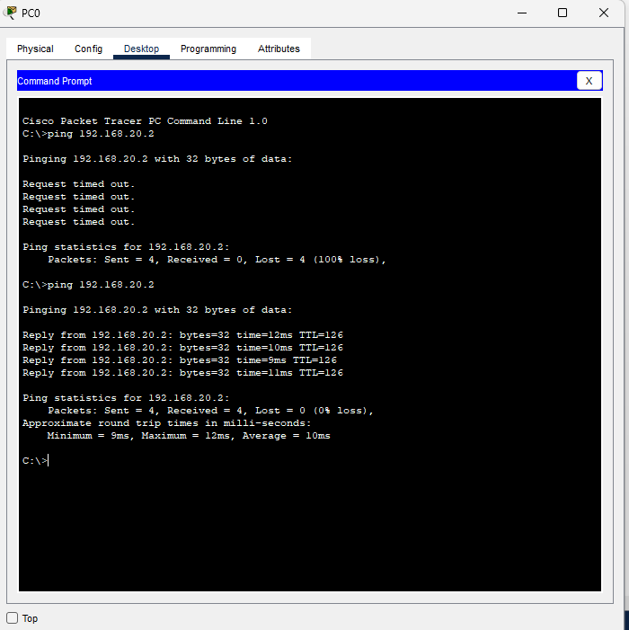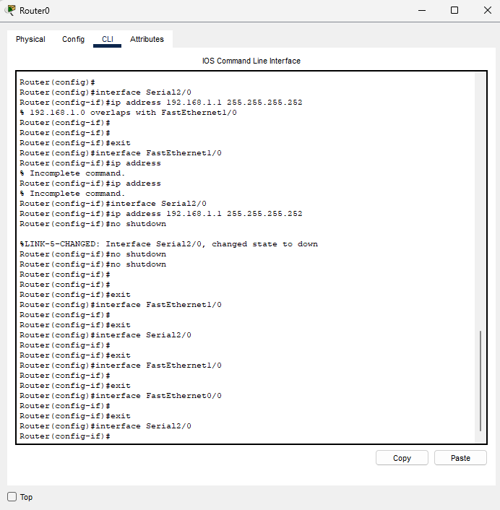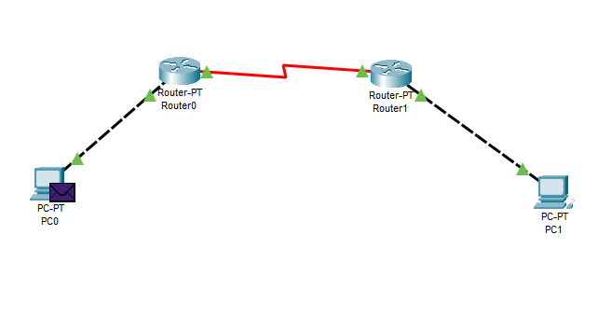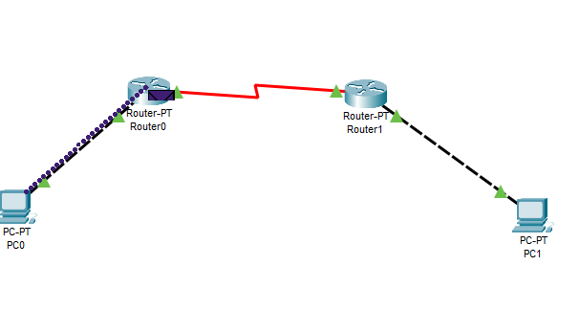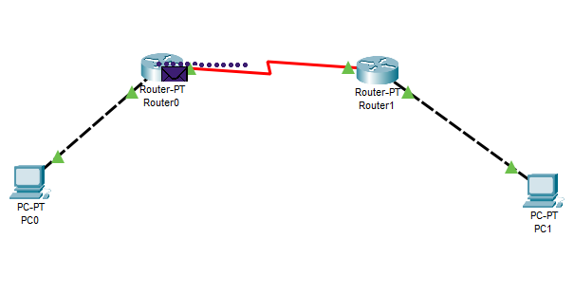

**Conclusion:**

In this experiment, we successfully configured static and default routing on routers to facilitate communication between different network segments. By setting up a network with multiple routers and PCs, we demonstrated how static and default routes ensure that data packets are correctly routed to their destination networks. The successful ping tests between the PCs confirmed the accurate configuration of routing tables, allowing for seamless data transfer across the network. This exercise highlighted the importance of static and default routing in managing network traffic efficiently and ensuring connectivity between devices on separate subnets.